**Student Study Portal**

**Project Synopsis**

**Major Project (ICI651)**

Degree

**BACHELOR OF COMPUTER APPLICATION**

PROJECT GUIDE: SUBMITTED BY:

**Mr. Shailendra Rawat Sachin Kumar (TCA2056020)**

**Vivek Pal (TCA2056027)**

**Senior IT Faculty, INurture Siddhartha (TCA2056022)**

**Tushar Vishnoi(TCA2056025)**

**CCSIT, TMU, Moradabad**

September, 2022



**FACULTY OF ENGINEERING & COMPUTING SCIENCES TEERTHANKER MAHAVEER UNIVERSITY, MORADABAD**

**Table of Contents**

1 Project Title 3

2 Domain 3

3 Problem Statement 3

4 Project Description 4

4.1 Scope of the Work 5

4.2 Project Modules 5

5 Implementation Methodology 6

6 Technologies to be used 7

6.1 Software Platform 7

6.2 Hardware Platform 7

6.3 Tools 7

7 Advantages of this Project 8

8 Future Scope and further enhancement of the Project 8

9 Team Details 8

10 Conclusion 8

11 References 9

# Project Title

The project title is ‘**Student Study Portal’**. The aim of the project is to build a website for students for making their notes online or storing the other learning things. The main objective of the system is learning but it also reduces the paper work in the present time.

# Domain

***Student Study Portal (Web Technology).***

Web technologies refers to the way computers/devices communicate. with each other using mark-up languages. It is communication across the web, and create, deliver or manage web content using hypertext markup language (HTML, CSS, BOOTSTRAP) .

# Problem Statement

The main objective of the **SSP** is to help the students get over the traditional methods of learning and make them accustomed to the internet where the notes for their respective subjects are easily available. It provides an automation procedure of studying the notes online.

This project not only helps to facilitate easier access to notes for the students but also helps cutting down on expenditure for the universities as well.

# Project Description

As mentioned earlier, this project is used to support students while utilizing all the available resources.

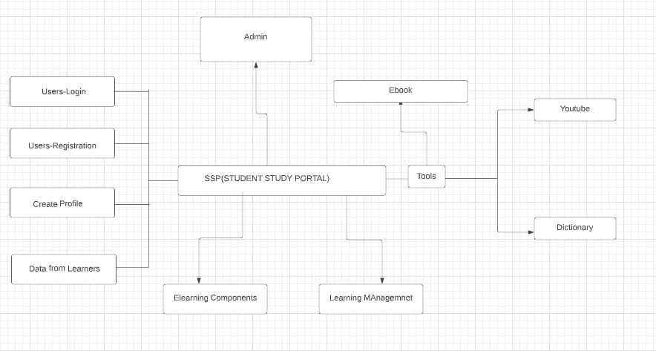

**Context Diagram**

## Scope of the Work

**Student Study Portal** also known as an **online learning** platform is where thousands of students can makes their notes online and able to access form anywhere and anytime.

SSP system makes education easier as there’s an availability of multimedia sources alongside textual materials for the students. This makes learning fun and engaging thereby making a progressive e-learning environment. The students who cannot commute to universities get the highest benefits out of using **SSP**. Flexibility in terms of time makes it easier to multitask and still get the best results.

## Project Modules

The project will contain the following modules:

1. Manage.py: It is the main file which contains the core configuration of the project.
2. Templates-It contains the all html files.
3. Static- It will contain the public/static files used in the projects like scripts, CSS files, images, etc.
4. SSP folder – It contains all files of the project like the URL file, setting file , views file.
5. Notes Module: Students can create online notes.
6. Books Module: Users can buy or read free books from the same portal.

# Implementation Methodology

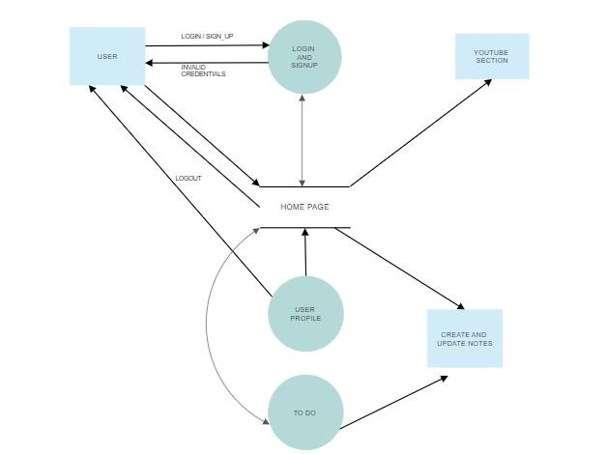

**Data Flow Diagram**

**The above diagram depicts the data flow of the project**

# Technologies to be used

The following technologies are utilized for this project. This list may change as need for more features/improvements arises in the future.

## Software Platform

1. **Front-end**
   * HTML, CSS

*We use HTML for building the basic structure of the website and CSS is used for the designing the webpage.*

* + Bootstrap/Tailwind CSS

*We use BOOTSTRAP and Tailwind CSS for the responsive view of the website.*

1. **Back-end** 
   * Python

*We use python because it is easy programming language than other language. We use python for BACKEND Development.*

* + Django(Framework)

It is a python framework we used this framework *because its provides numbers of library which helps easy development.*

1. **Database** 
   * Sqlite/ Django Admin Panel

## Hardware Platform

* 4 GB RAM
* 500gb Hard Disk,
* Windows 10,
* Google Chrome v105.0.5195.

## Tools

During the planned development phase, the main tool is **VS Code v1.71** by Microsoft used as an editor for quick and precise development of the project.

# Advantages of this Project

The main advantages of this project are:

* Able to access the notes from anywhere at anytime.
* No possibility of lose the data.
* Free access to all features from signup.
* It is smart learning application.
* Avoid the paper use.

# Future Scope and further enhancement of the Project

The possible enhacement may be a separate section for Teachers to upload the lectures and a central library for students to access the books on the same portal.

# Team Details

|  |  |  |  |  |  |
| --- | --- | --- | --- | --- | --- |
| **Project Name & ID** | **Course Name** | **Student ID** | **Student Name** | **Role** | **Signature** |
|  |  | TCA2056020 | Sachin Kumar | Front-end Developer |  |
| TCA2056027 | Vivek Pal | HTML,CSS |  |
|  |  | TCA2056022 | Siddhartha | Backend Developer |  |
|  |  | TCA2056025 | Tushar Vishnoi |  |  |
|  |  |  |  |  |  |
|  |  |  |  |  |  |
|  |  |  |  |  |  |

# Conclusion

SSP or **Student Study Portal** is **website that offers a platform to manage learning resources and contents**. It helps the students to handle all the resources used in the learning process.

# References

1. <https://www.free-ebooks.net/> : for accessing E-books.
2. <https://cloud.smartdraw.com/>: we use this website for making the Data Flow Diagram.
3. <https://creately.com/>: we use this website for making the context Diagram.
4. <https://www.wikipedia.org/>: we use this website for searching the Wikipedia content.